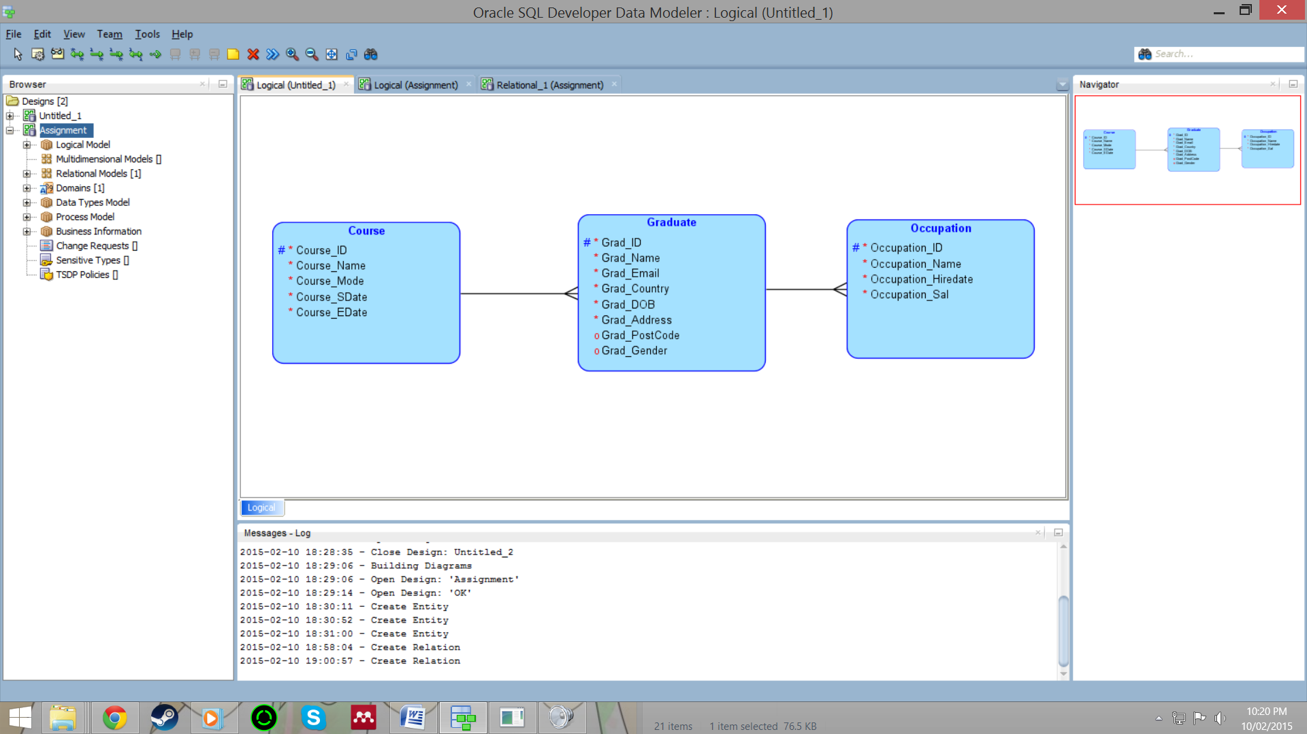**Initial logical model:**

Course -

* Course_ID - Unique course ID
* Course_Name - The name of the course
* Course_Mode - Full time or part time study
* Course_SDate - When the course started
* Course_EDate - When the course ended

Graduate - (perhaps change this to student if all values will be from university database as if graduation)

* Grad_ID - Unique graduate ID
* Grad_Name - Name of the graduate (surname)
* Grad_Email - Graduates email
* Grad_Country - Country of origin
* Grad_DOB - Date of birth
* Grad_Address - Graduates address during time of study (perhaps after graduation)
* Grad_PostCode - Graduates post code during time of study (perhaps after graduation)
* Grad_Gender - Gender of the graduate

Occupation -

* Occupation_ID - Unique Occupation ID
* Occupation_Name - Name of the occupation
* Occupation_Hiredate - Date hired
* Occupation_Sal - Annual salary of occupation

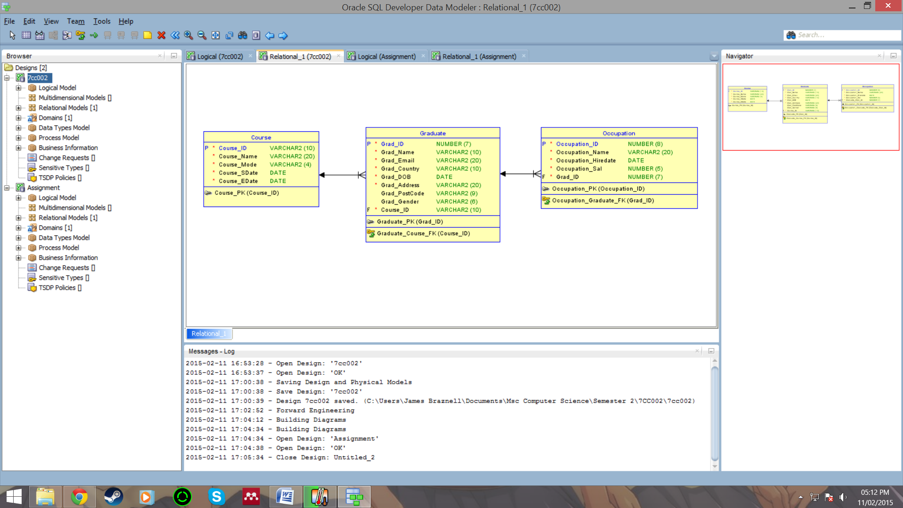**Initial relational model -**

Course -

* Course_ID - Varchar2 with a maximum length of ten
* Course_Name - Varchar2 with a maximum length of twenty
* Course_Mode - Varchar2 with a maximum length of four
* Course_SDate - Date type
* Course_EDate - Date type

Graduate -

* Grad_ID - Number with a maximum length of seven
* Grad_Name - Varchar2 with a maximum length of ten
* Grad_Email - Varchar2 with a maximum length of twenty
* Grad_Country - Varchar2 with a maximum length of ten
* Grad_DOB - Date type
* Grad_Address - Varchar2 with a maximum length of twenty
* Grad_PostCode - Varchar2 with a maximum length of nine
* Grad_Gender - Varchar2 with a maximum length of six
* Course_ID - Foreign key linking to course table as Varchar2 with maximum length of ten

Occupation -

* Occupation_ID - Number with a maximum length of eight
* Occupation_Name - Varchar2 with a maximum length of twenty
* Occupation_Hiredate - Date type
* Occupation_Sal - Number with a maximum length of five
* Grad_ID - Foreign key linking to graduate table as Number with a maximum length of seven